CPU's

GPU's

RAM

GPU

Memory

System Bus

Video  
Display

CPU's

GPU's

RAM

GPU

Memory

System Bus

Video  
Display

JavaScript Code

Data

Stored  
here

Executed  
here

Model  
Data

Shader  
Code

Stored  
here

Executed  
here

Stored  
here

OpenGL 4.6

OpenGL 1.4

OpenGL 2.1

OpenGL 1.2

OpenGL 1.1

OpenGL 1.0

OpenGL 2.0

OpenGL 1.3

OpenGL 1.5

OpenGL 3.0

OpenGL 4.4

OpenGL 3.3

OpenGL 4.5

OpenGL 4.2

OpenGL 4.0

OpenGL 3.1

OpenGL 3.2

OpenGL 4.1

OpenGL 4.3

Jul 2003

Jul 2002

Aug 2001

Mar 1998

Mar 1997

Jan 1992

Jul 2006

Sep 2004

Mar 2010

Mar 2010

Aug 2009

Mar 2009

Aug 2008

Jul 2010

Aug 2011

Aug 2012

Jul 2013

Aug 2014

Jul 2003

OpenGL ES 1.0

OpenGL ES 1.1

OpenGL ES 2.0

WebGL 1.0

Mar 2007

Mar 2011

OpenGl 4.2

OpenGl 4.3

WebGL 2.0

OpenGL ES 3.0

Aug 2012

Jan 2017

OpenGL ES 3.1

Mar 2014

Aug 2015

OpenGL ES 3.2

Jul 2017

INPUT: model (x,y,z) vertices

**Vertex Shader**

Viewport

Transform

Rasterizer

**Fragment Shader**

Compositing

OUTPUT: pixel colors in frame buffer

**gl_Position**

**gl_FragColor**

Graphics Pipeline

**Model View**

**Transform**

**Projection**

**Transform**

**Normalize & Clip**

**Transform**

Viewport

Transform

Rasterize

Compositing

INPUT: model (x,y,z) vertices

**Shading**

Clipping

**Model View**

**Transform**

**Projection**

**Transform**

**Normalize & Clip**

**Transform**

Viewport

Transform

Rasterize

Compositing

INPUT: model (x,y,z) vertices

OUTPUT: pixel colors in frame buffer

OUTPUT: pixel colors  
in frame buffer

**Shading**

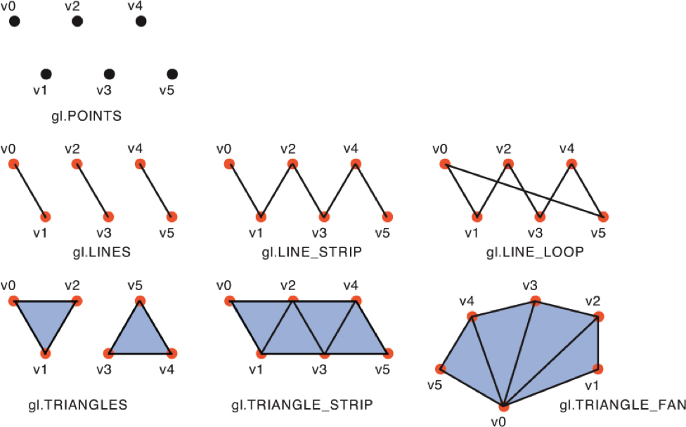

INPUTS:  
 shader attributes  
shader uniforms

CPU

**Vertex Shader**

GPU

GPU

Clipping

Rasterize

Viewport

Transform

GPU

GPU

**Fragment Shader**

GPU

GPU

Compositing

OUTPUT: framebuffer containing image

GPU